**Digital Forensics**

**Mid Lab Report**

**Submitted to: Sir Mustafa Khattak**

**By: Irum Imtiaz**

**Practical Windows Forensics**

**Name: Irum Imtiaz**

**Registration no: FA22-BCT-011**

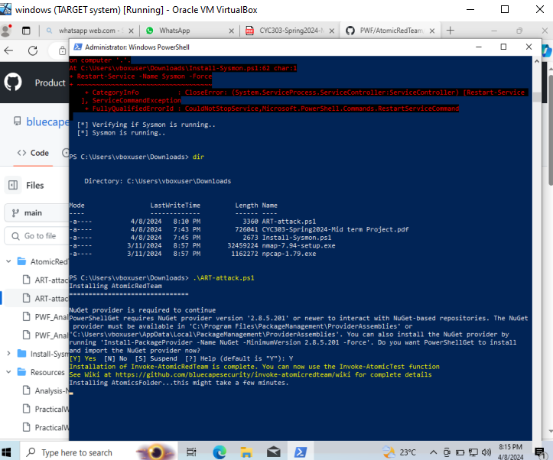**Executing atomic attack file on target system**

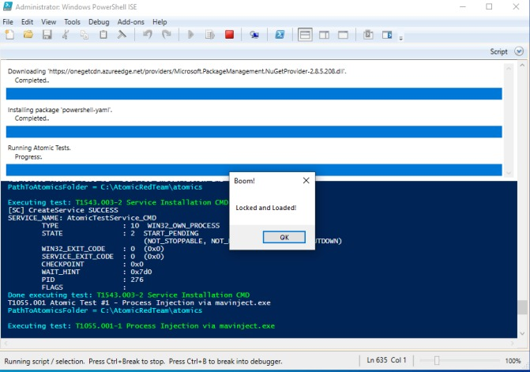

**Acquisition of memory and disk file and calculating their hash**



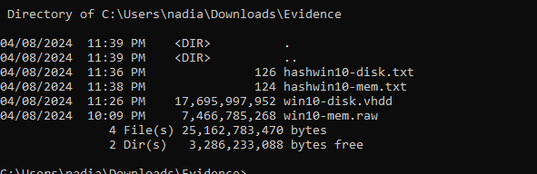

**Setting up workstation downloading tools saving snapshot of workstation**

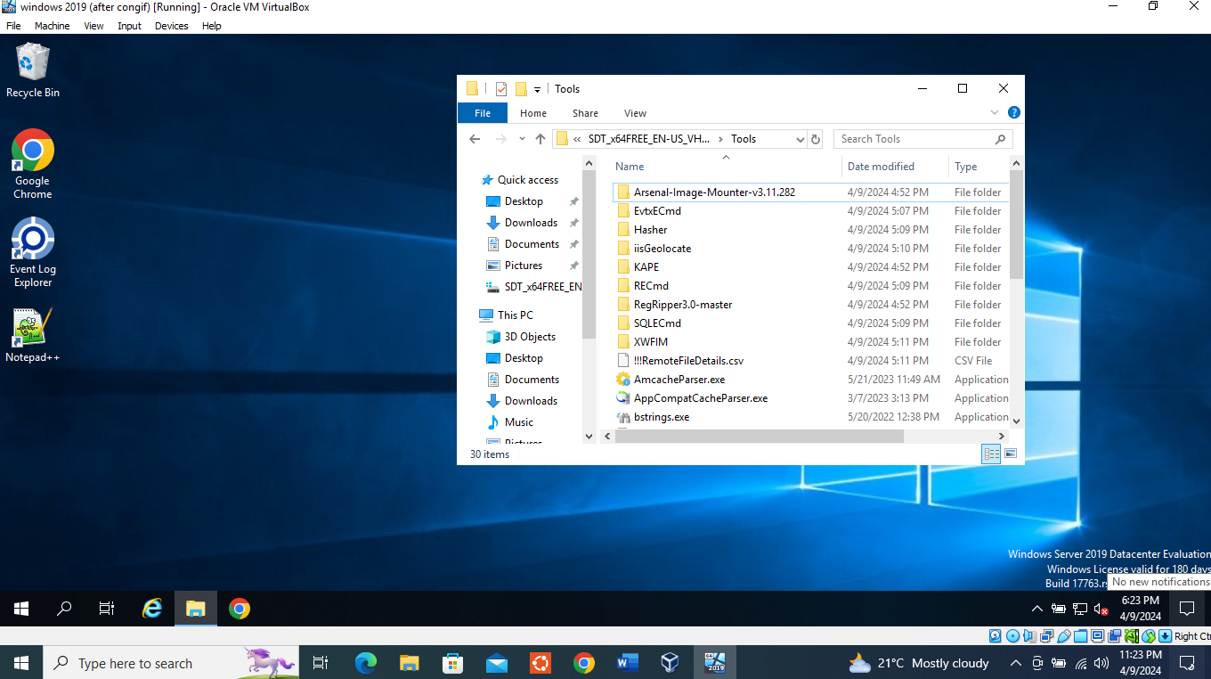

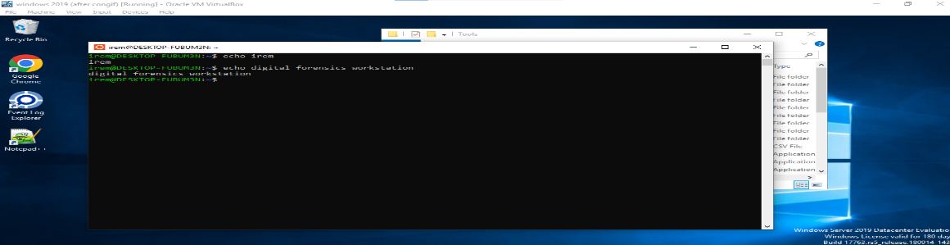

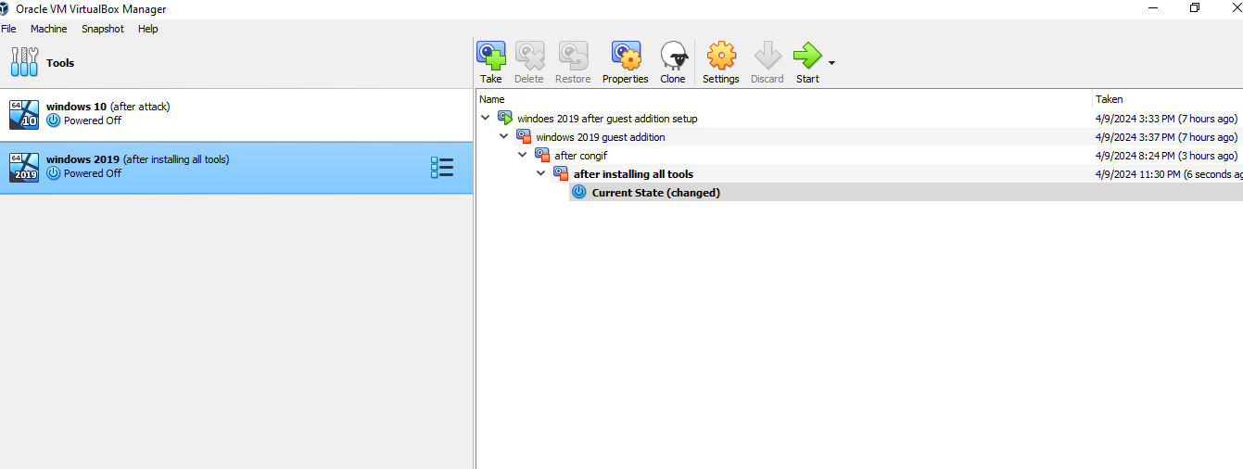

**Performing Analysis on disk and memory image**

**System Information**

Computer name: DESKTOP-VF4N211

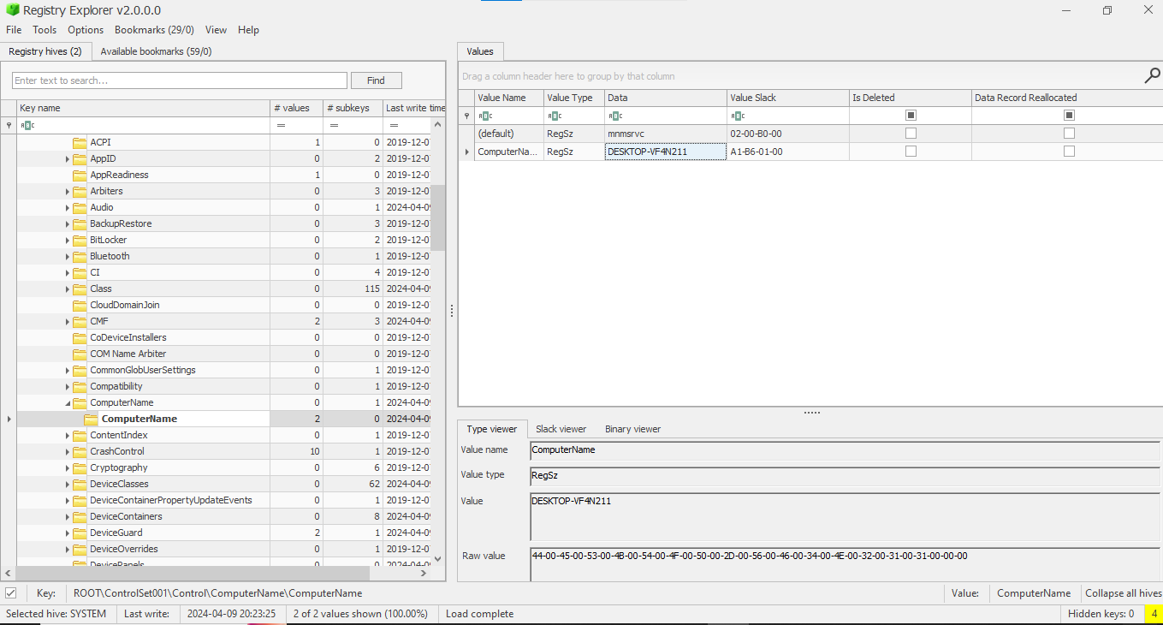

Windows Version:

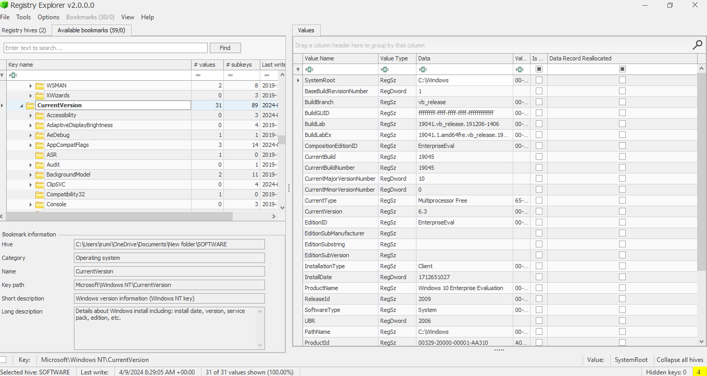

Time zone:

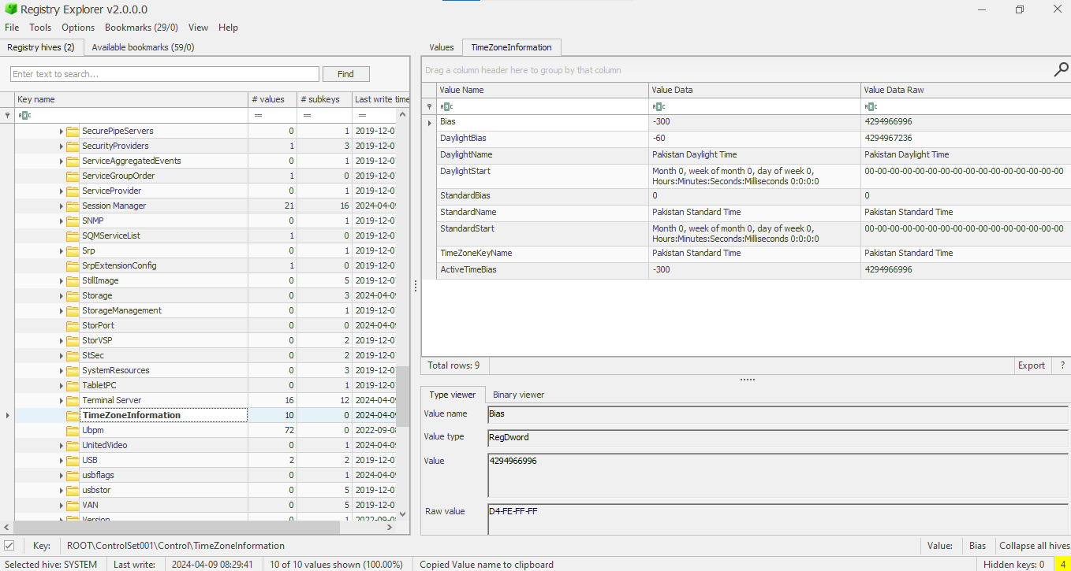

Network Information:

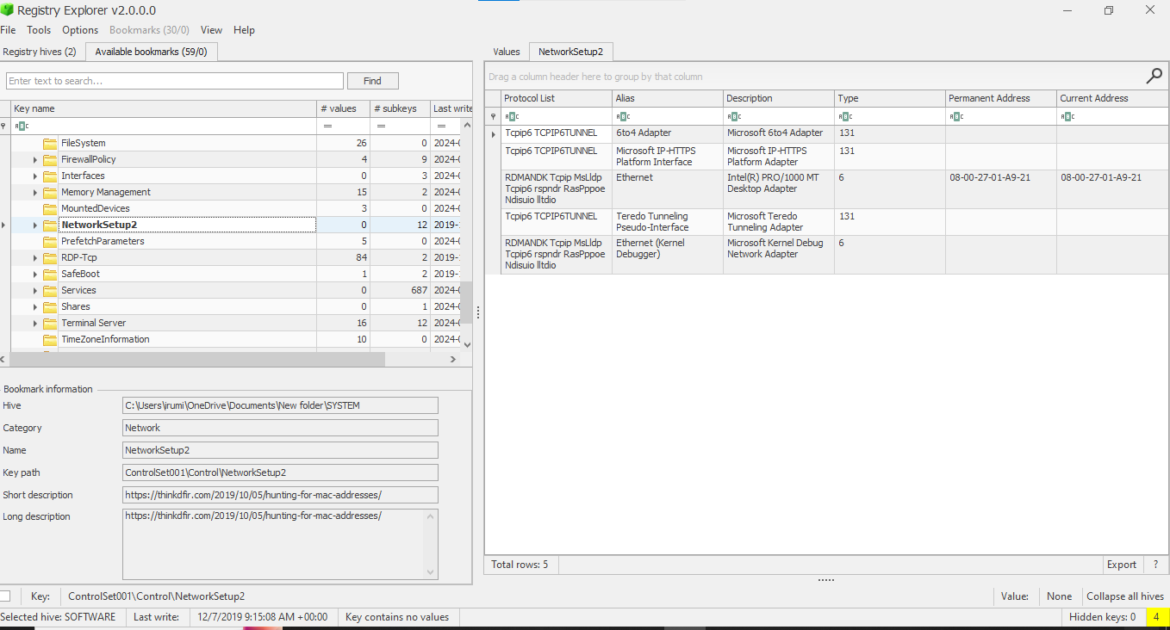

Shutdown time:

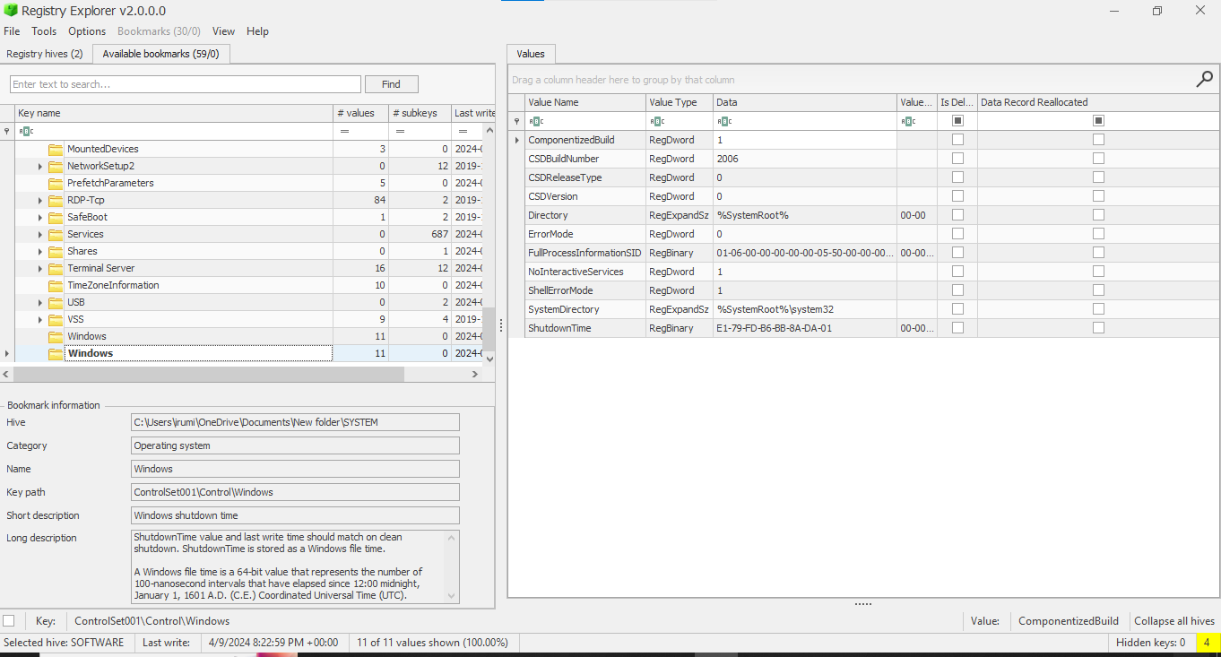

Defender settings:

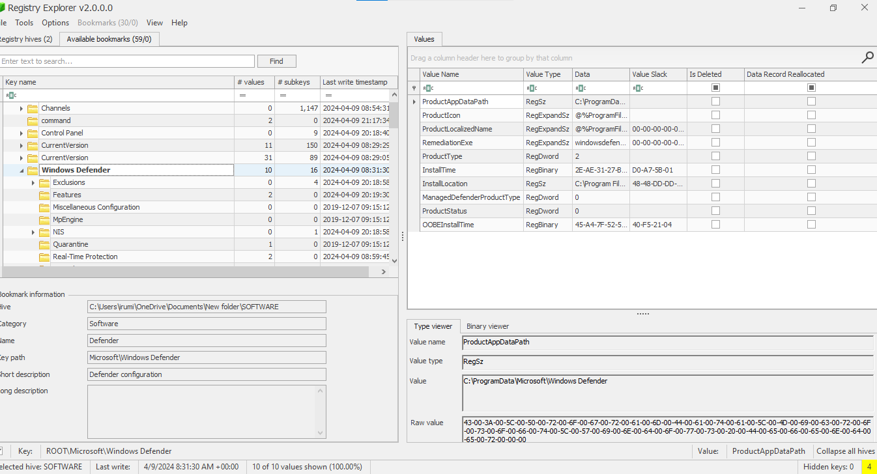

**Users, Groups and User Profiles**

Active accounts during the attack timeframe?

id: 1001 1002 500

User: irem art-test administrator

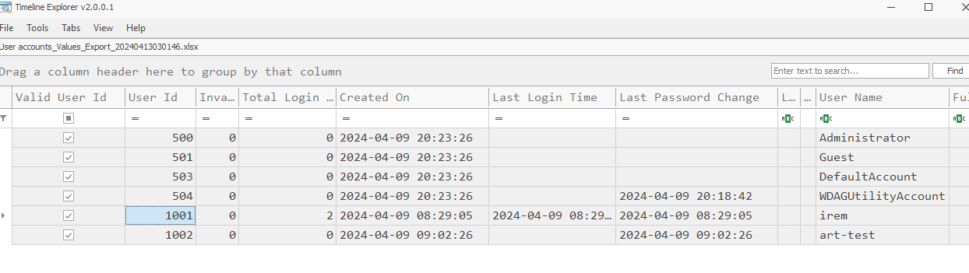

Which account(s) were created?

User: Art test id :1002

Which accounts are Administrator group members?

id: 1001 1002 500

User: irem art-test administrator

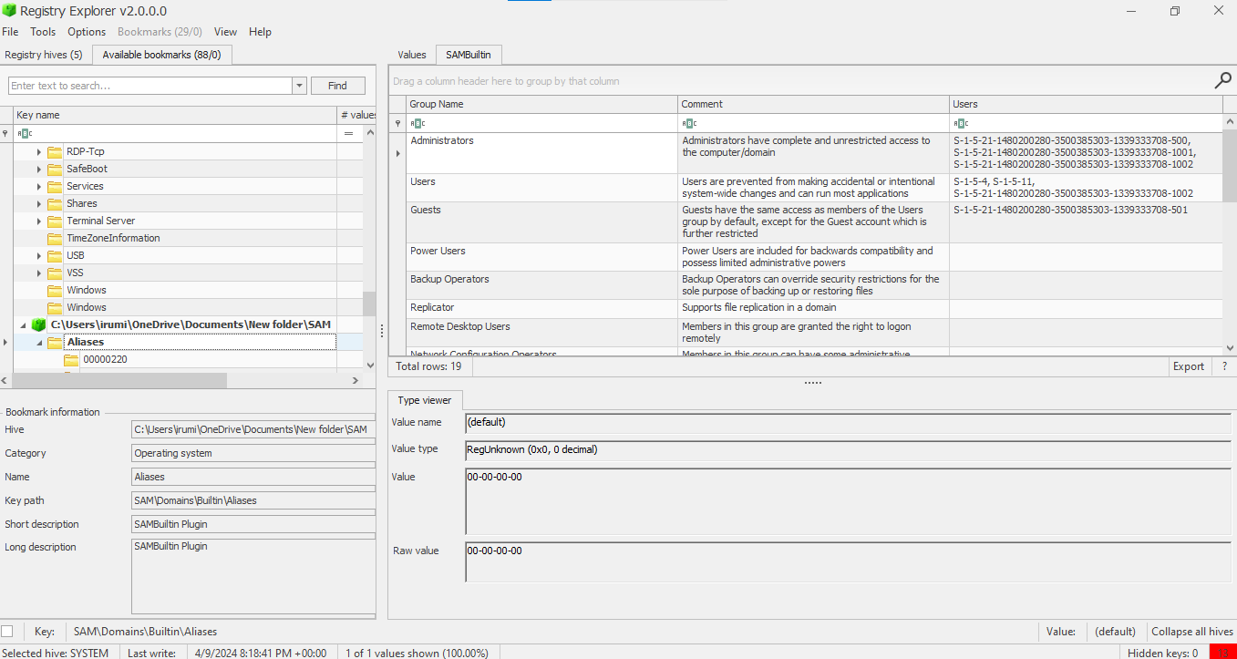

Which users have profiles?

User: irem

Path: C:\User\irem (other are built-in accounts)

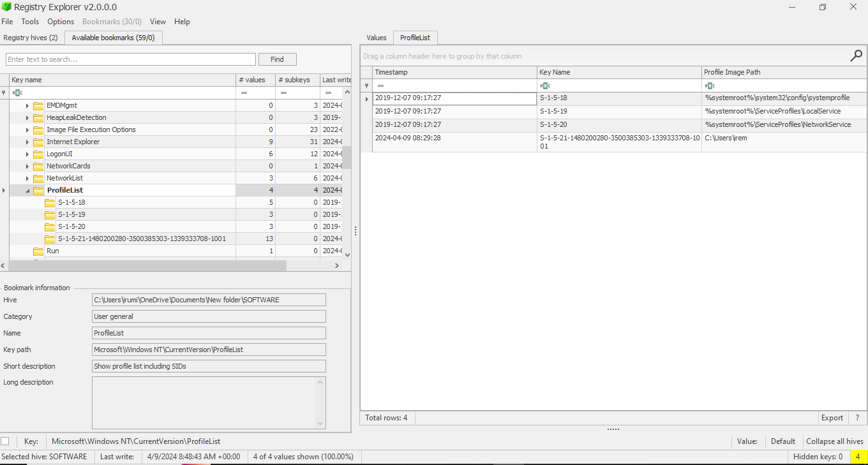

**User Behavior**

User Assist: Applications opened Files and folders

Shortcut link to start programs.

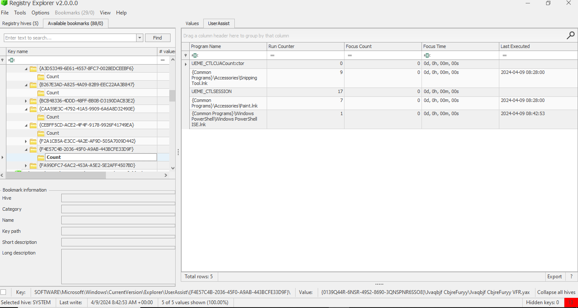

Applications,lisnks that have been accessed

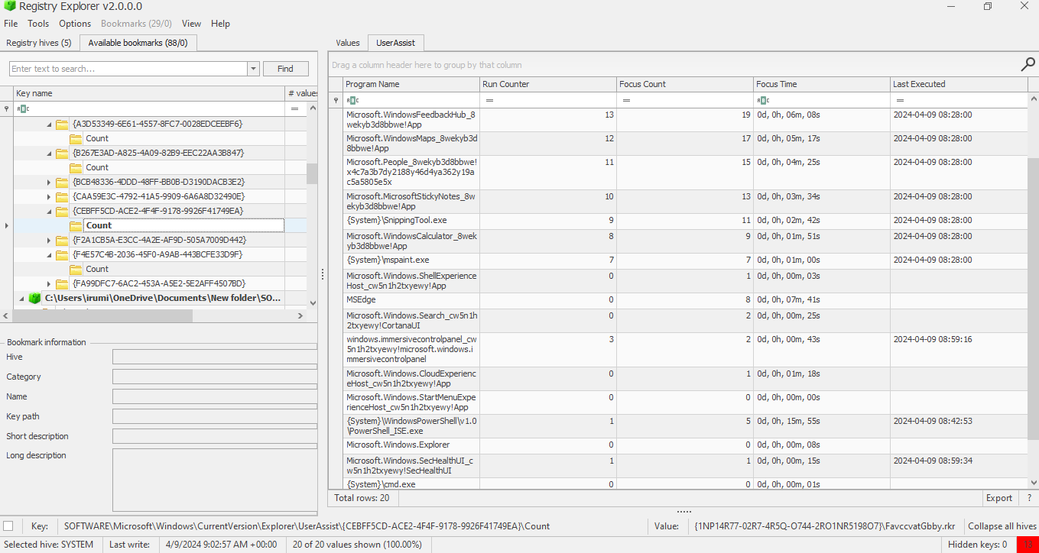

Recent documents

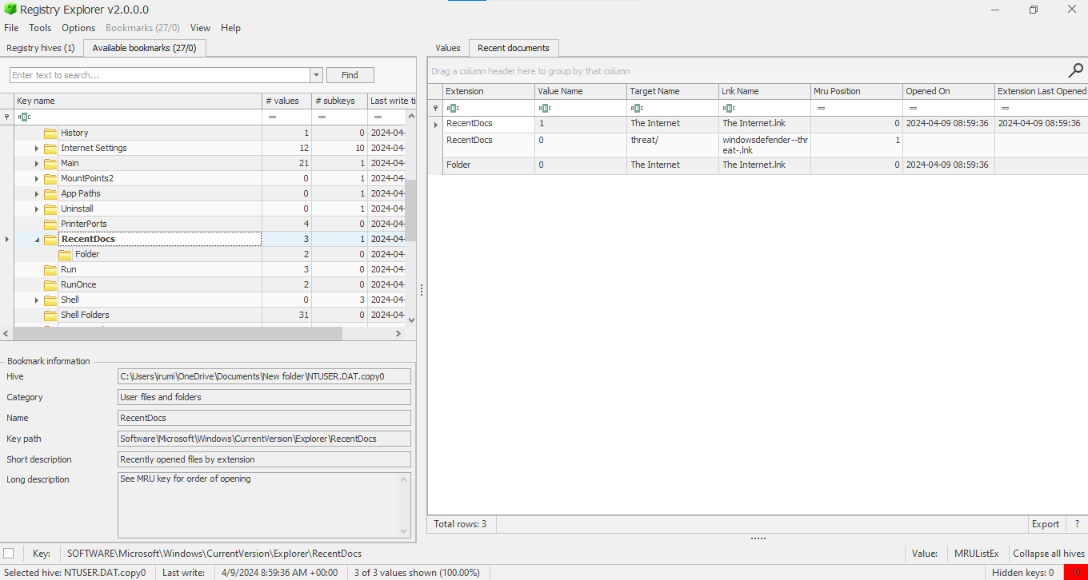

Shellbags

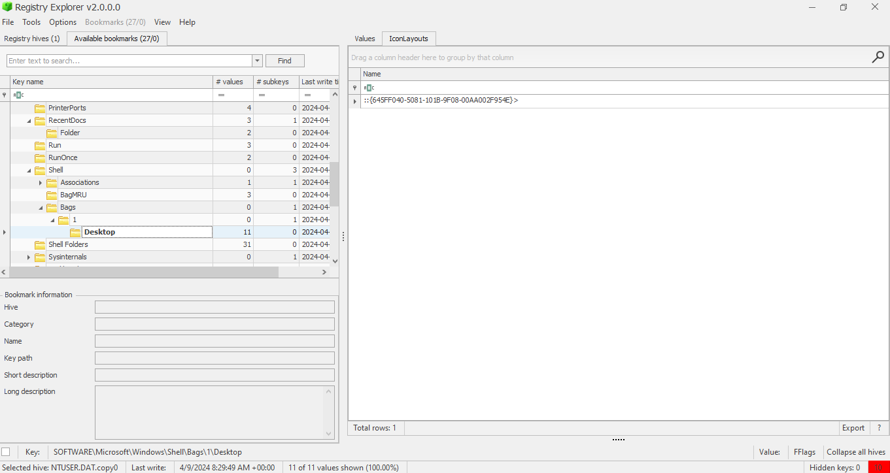

Open / Save MRU: 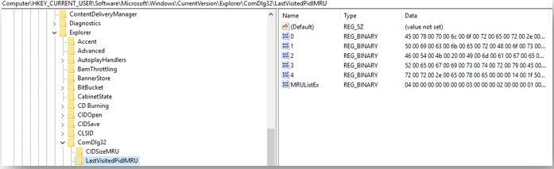

Last-Visited MRU:

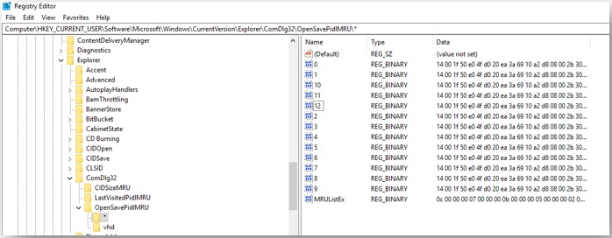

**NTFS - File System Analysis**

**Which files are located in My Computer\CLSID_Desktop\PWF-main\PWF-main\AtomicRedTeam?**

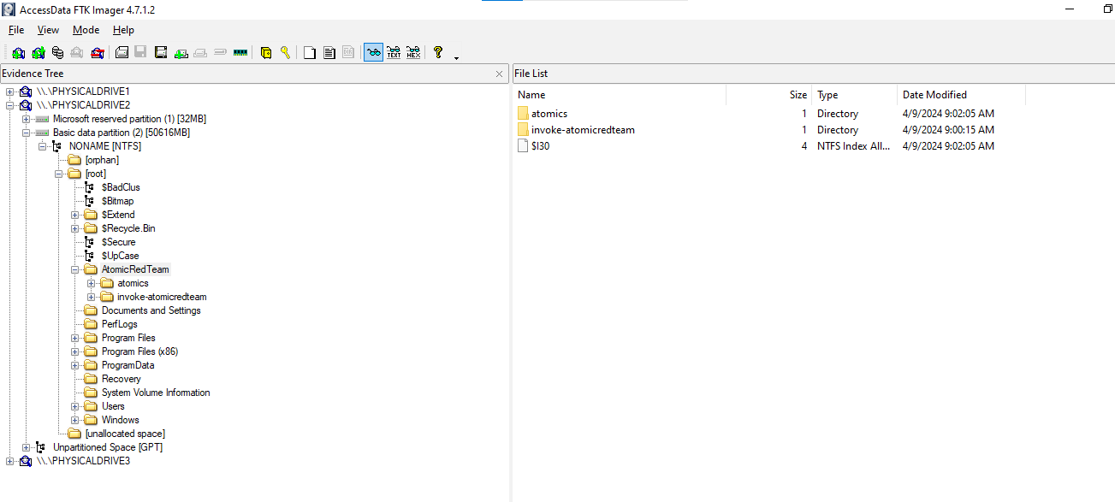

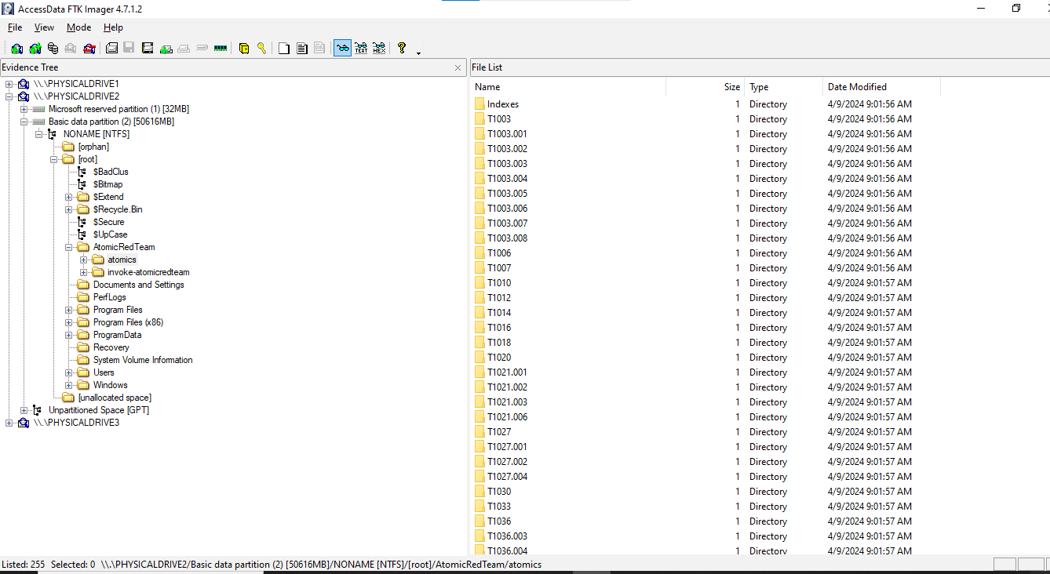

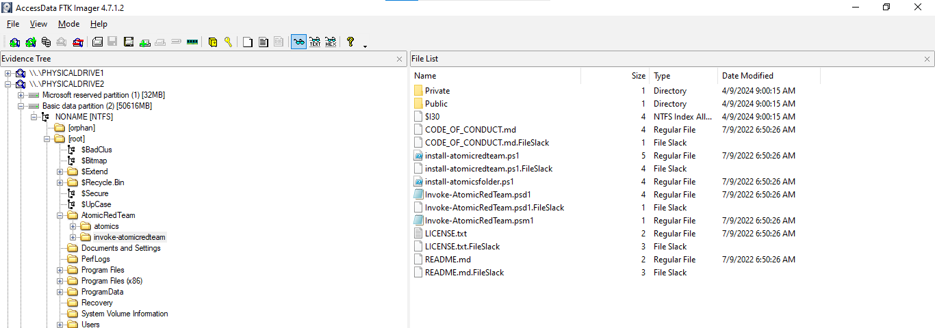

**What is the MFT Entry Number for the file "ART-attack.ps1"? 35,217**

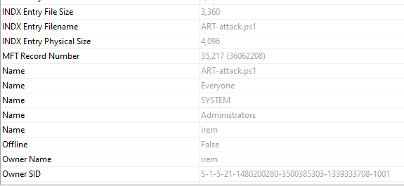

**What are the MACB timestamps for "ART-attack.ps1"?**

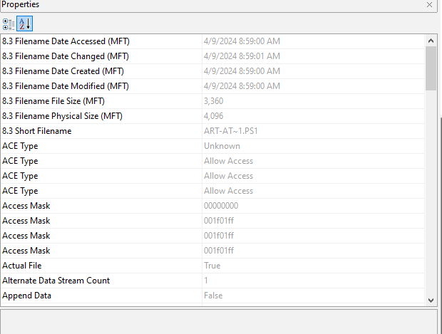

**Was "ART-attack.ps1" time stomped?**

Yes it was time stomped as the time

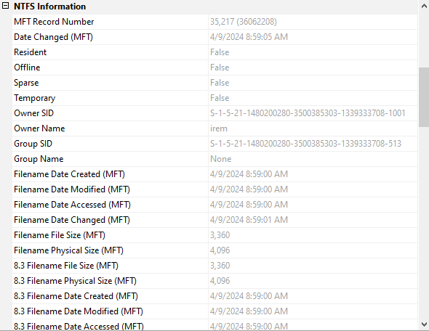****

When was the file "deleteme_T1551.004" created and deleted? What was the Entry number for "deleteme_T1551.004" and does it still exist in the MFT?

For me it is deleting t1070.004 file

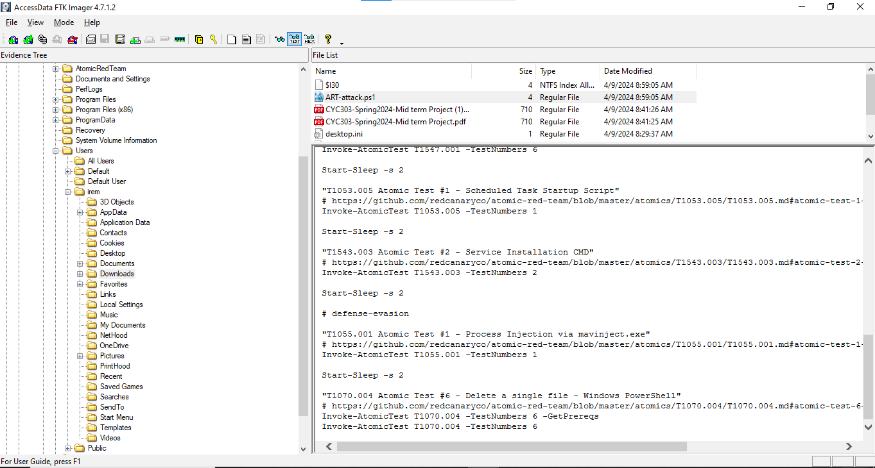



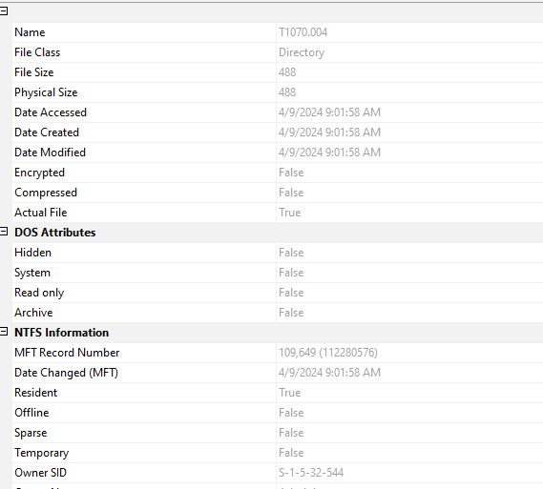

**Execution Artifacts**

which executables (.exe files) did the BAM record for the IEUser (RID 1000) incl. their last execution date and time?

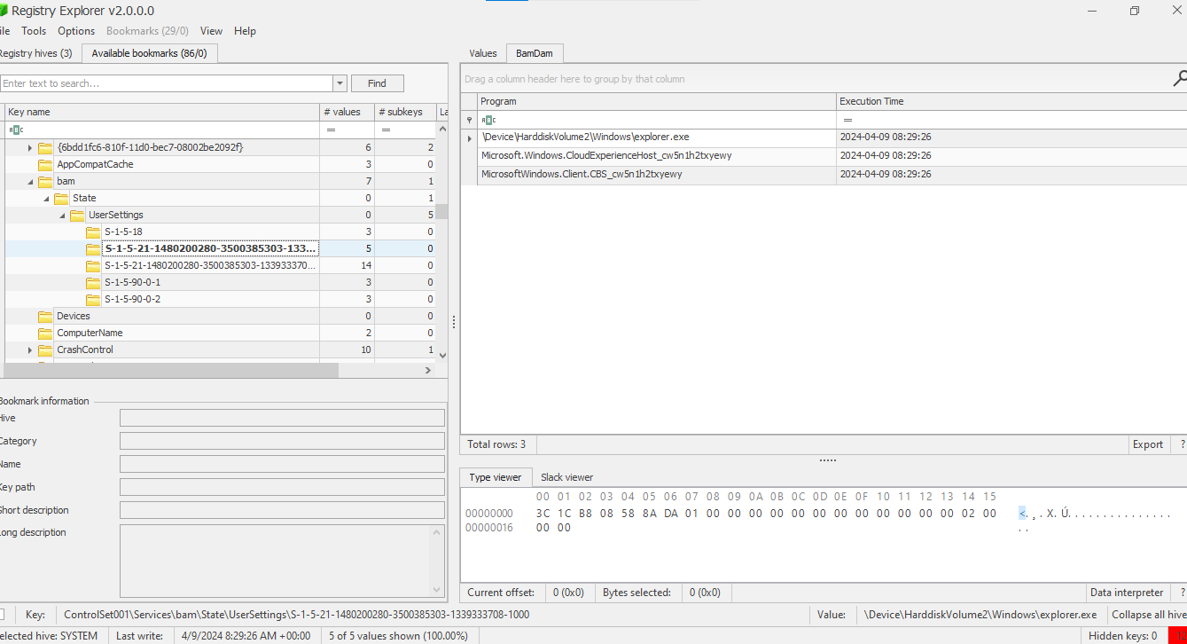

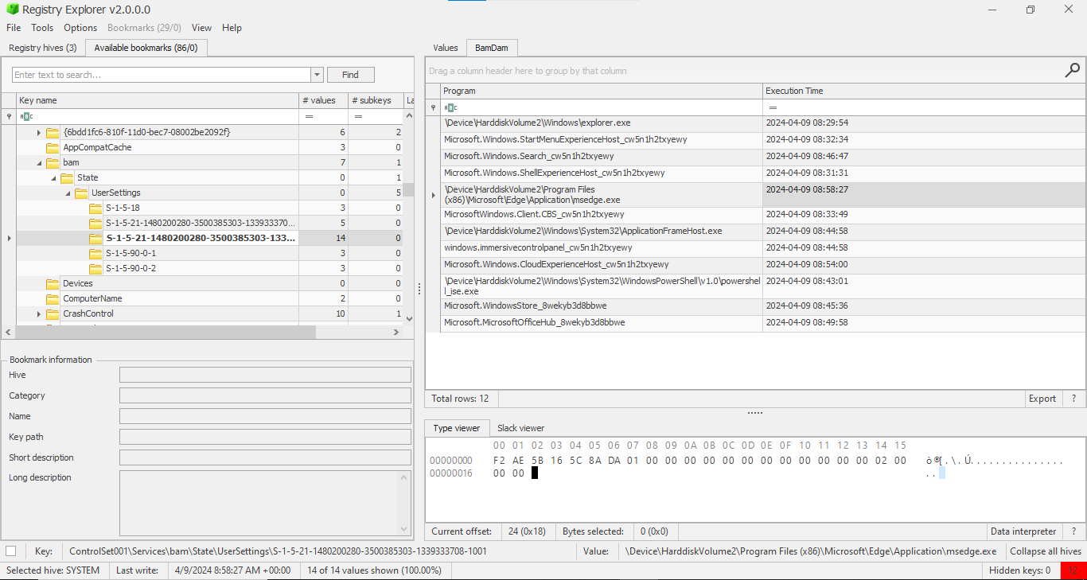

Determine the cache entry position for:

• AtomicService.exe: 4 • mavinject.exe: 5

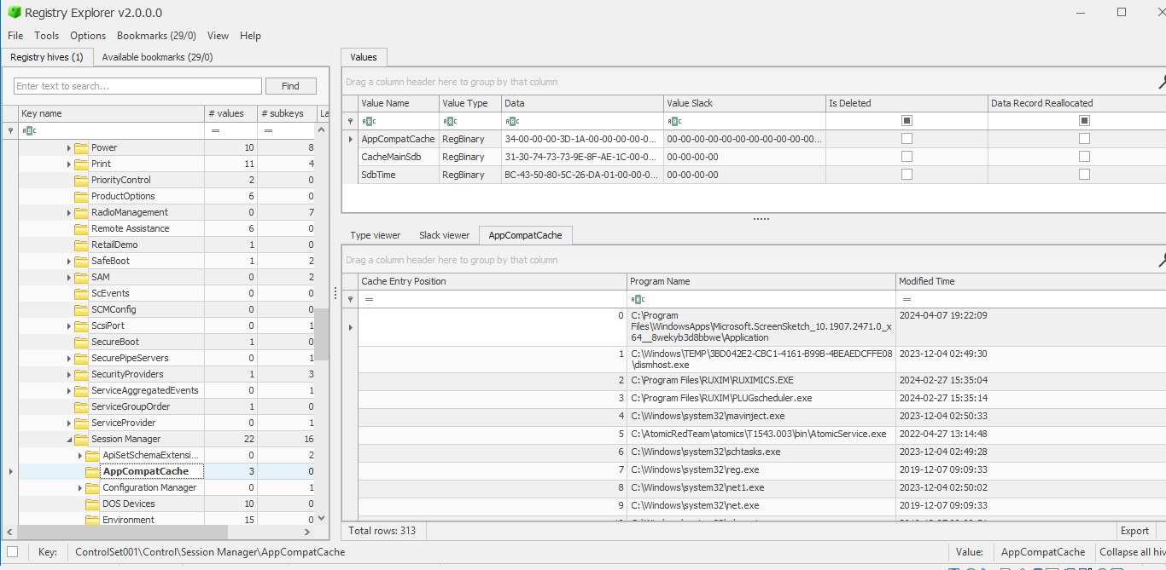

What SHA-1 hash did Amcache record for AtomicService.exe?

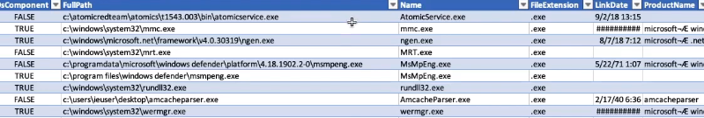

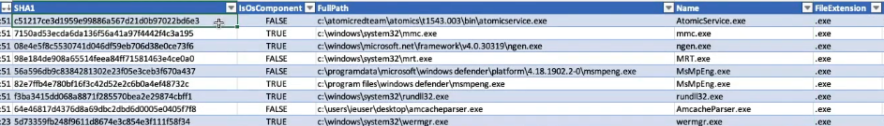

Prefetch Path: C:\Windows\Prefetch\*.pf Use the Prefetch-Timeline output to produce a timeline of suspicious execution events in the Eric Zimmerman Timeline



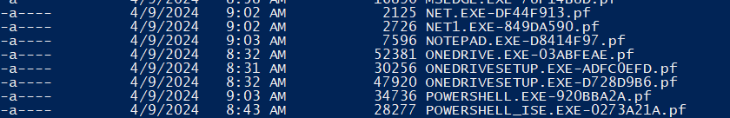



**Whole output**

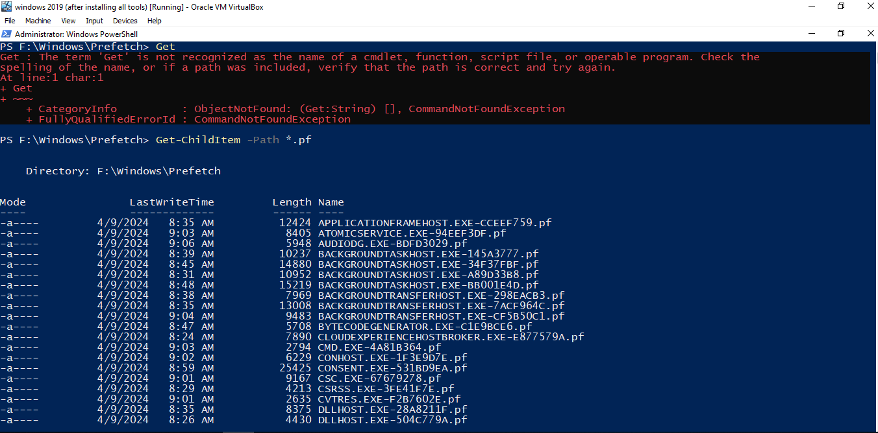

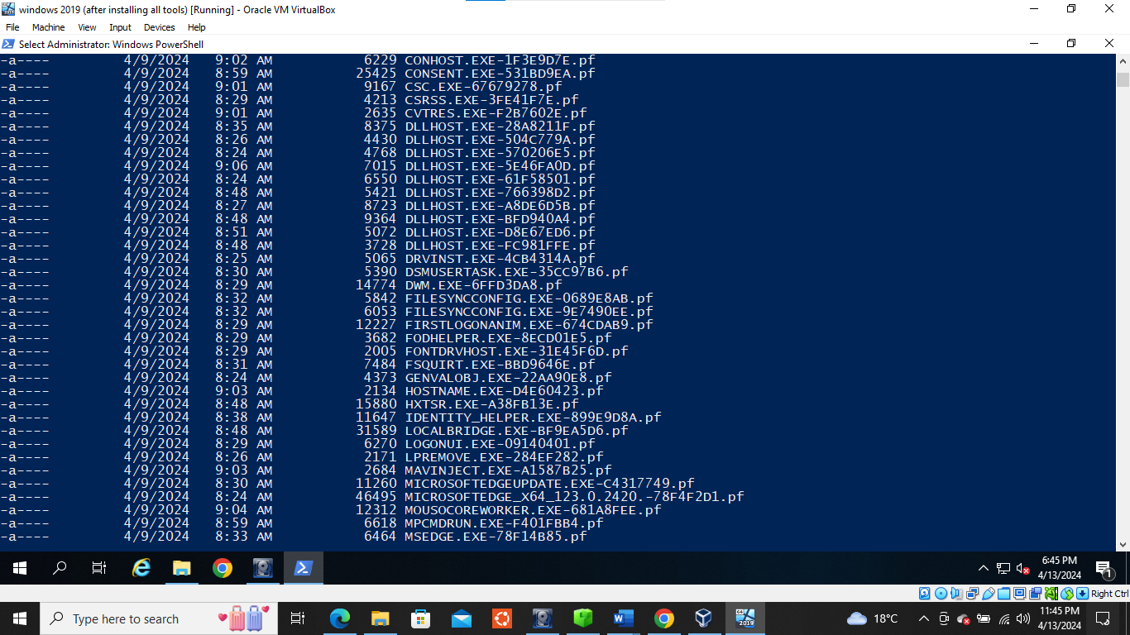

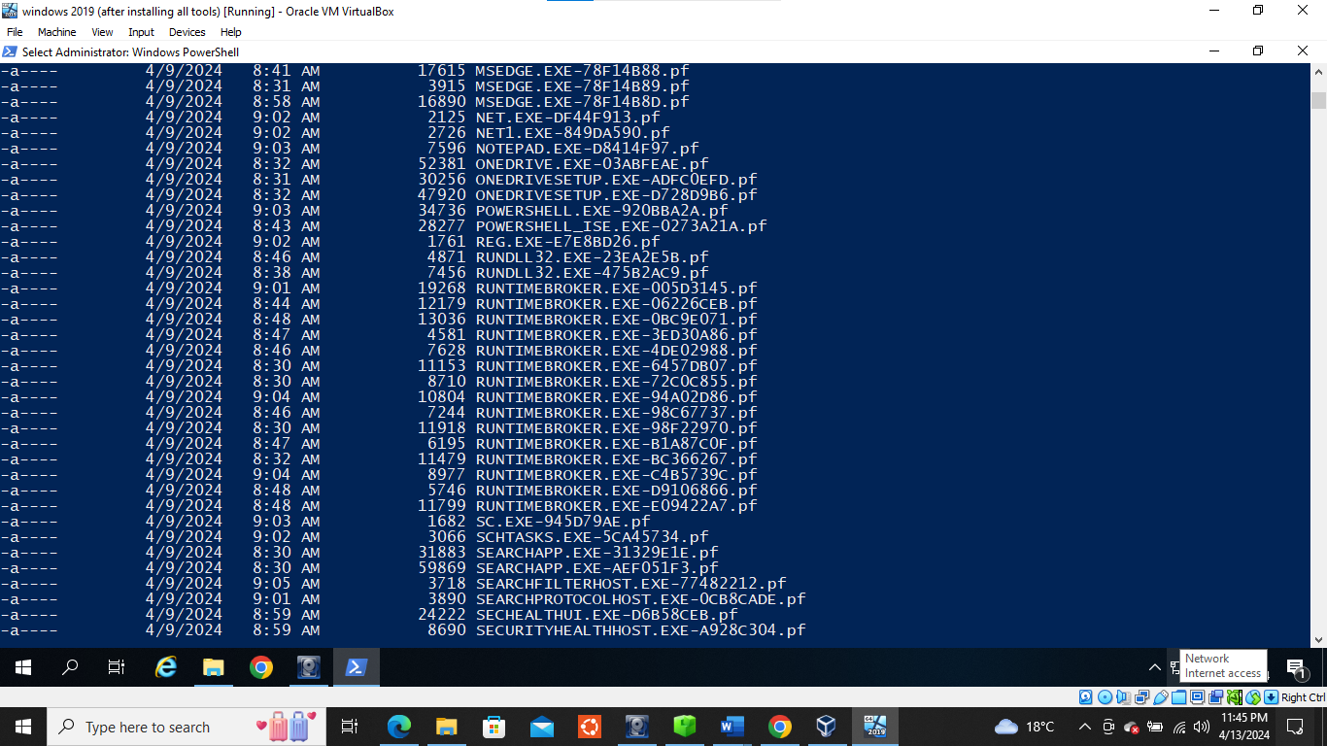

**Shortcut (LNK) Files**

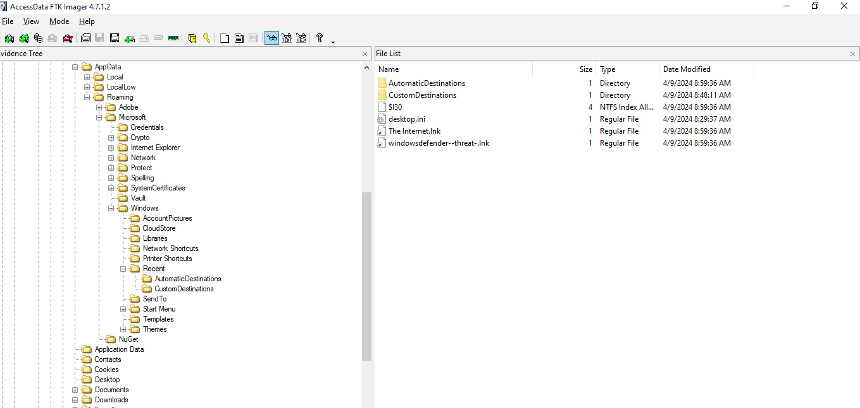

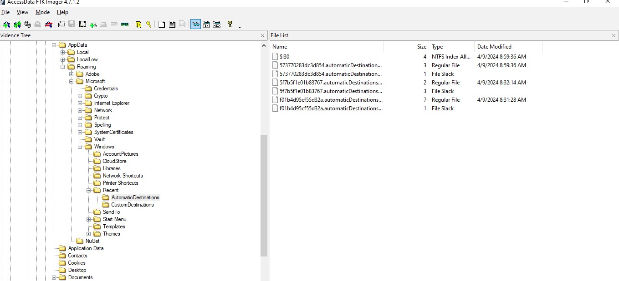

**Persistence Mechanisms**

What is the full path of the AtomicService.exe that was added to the run keys? C:\Path\AtomicRedTeam.exe

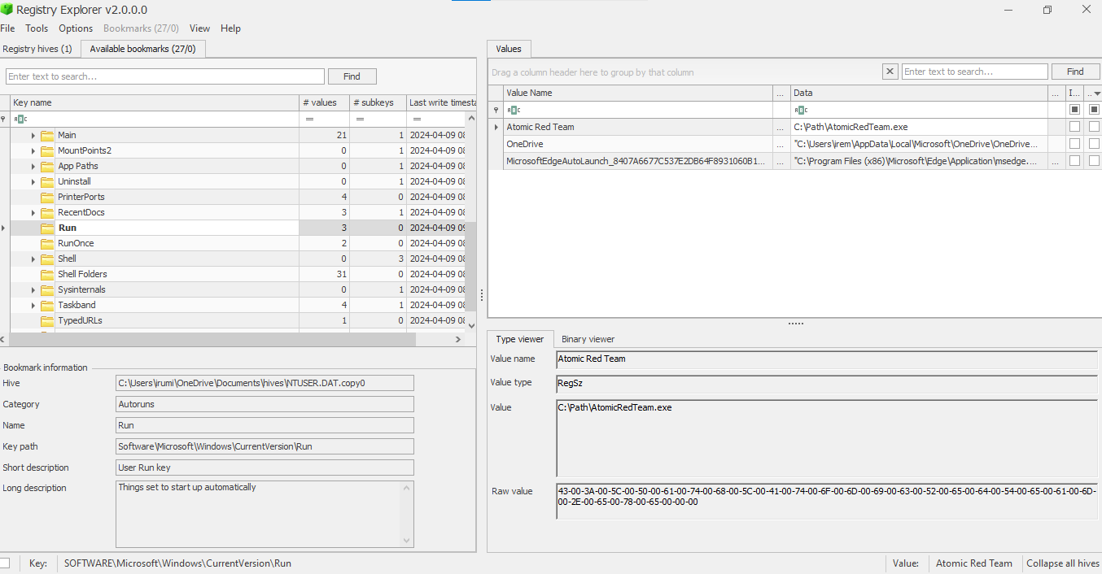

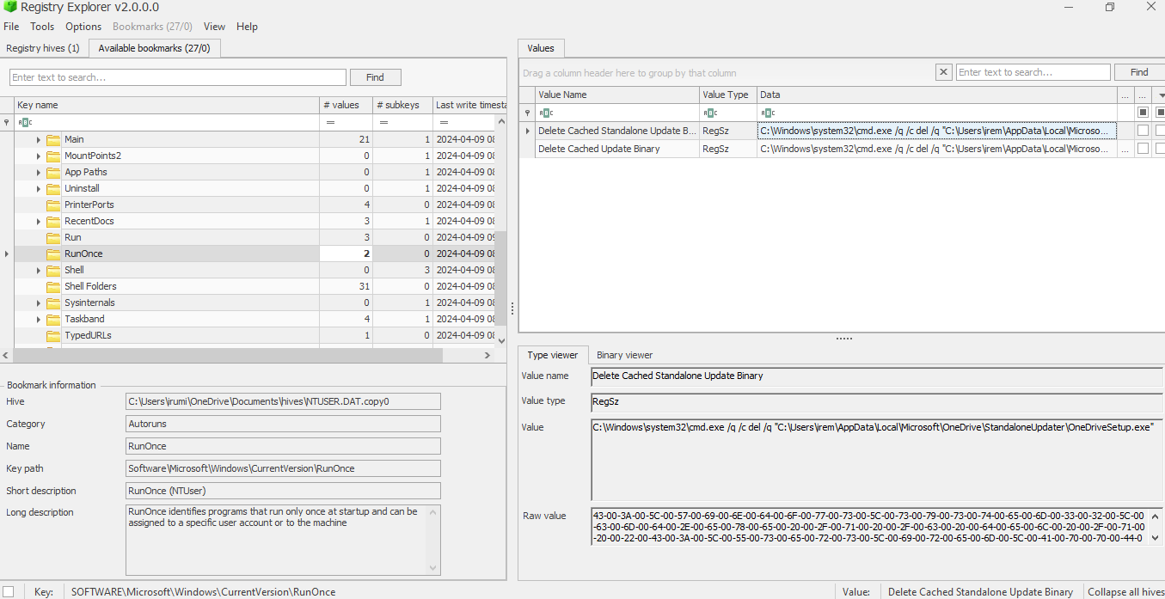

**Startup folder**

What is the name of the suspicious script in the Startup folder?

Batstartup.bat

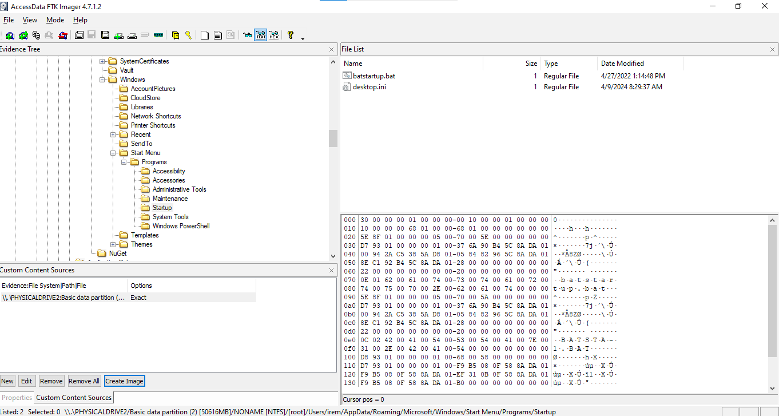

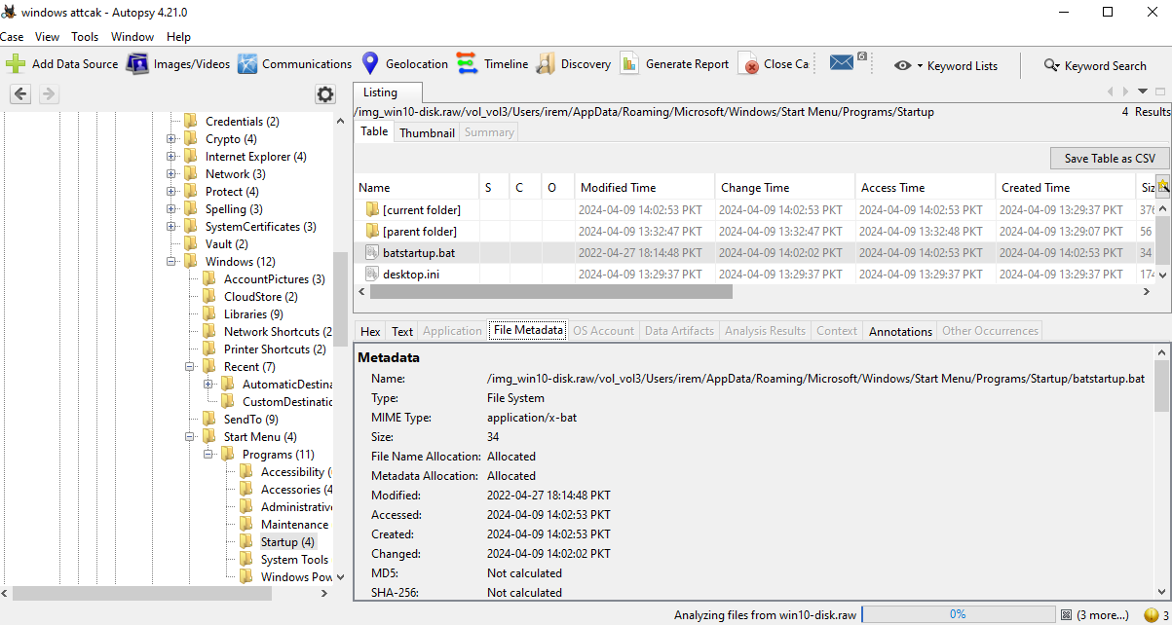

**Windows services**

When was the suspicious atomic service installed? 2024-04-09 10:51:50

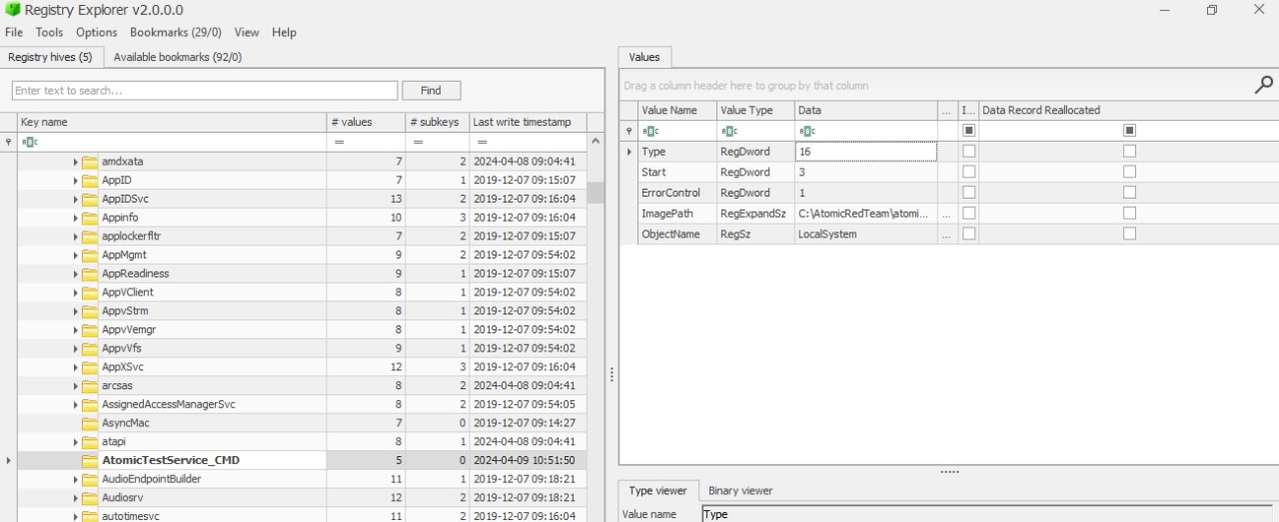

**Scheduled Tasks**

Which tasks were created by the IEUser and what's the creation time? How many times did they execute?

**First, I found data of users 1001 from tree folder**

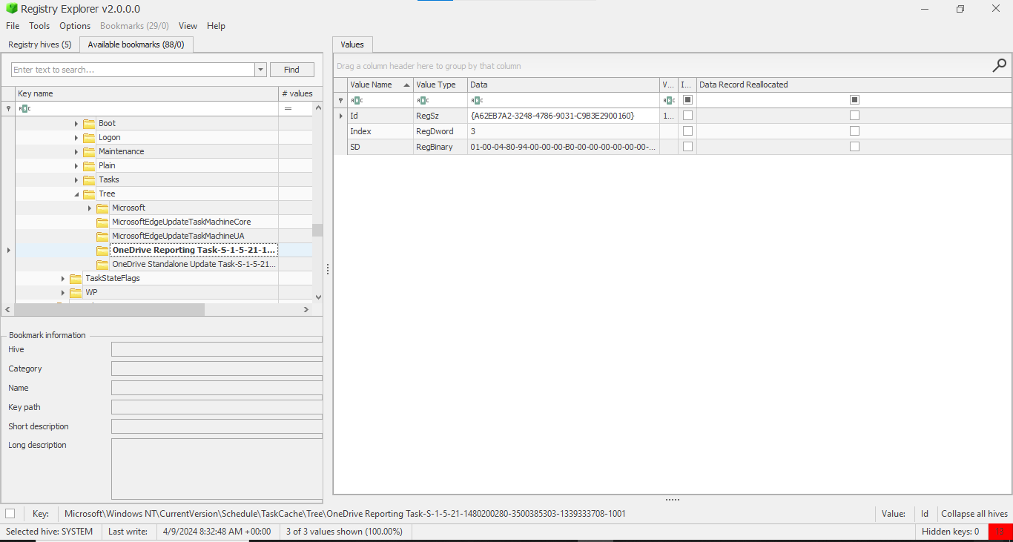

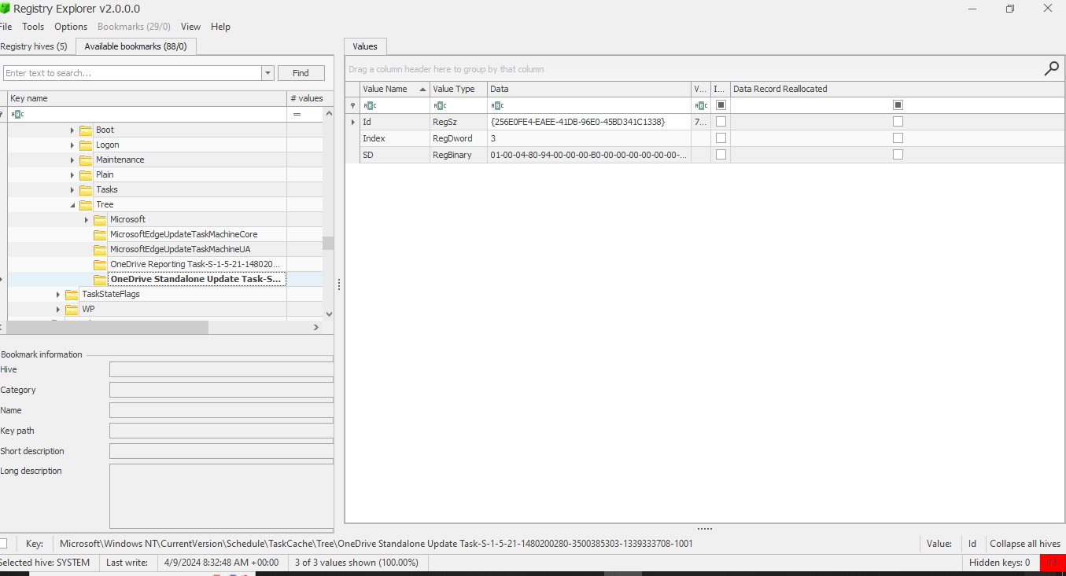

**Then I search in task folder**

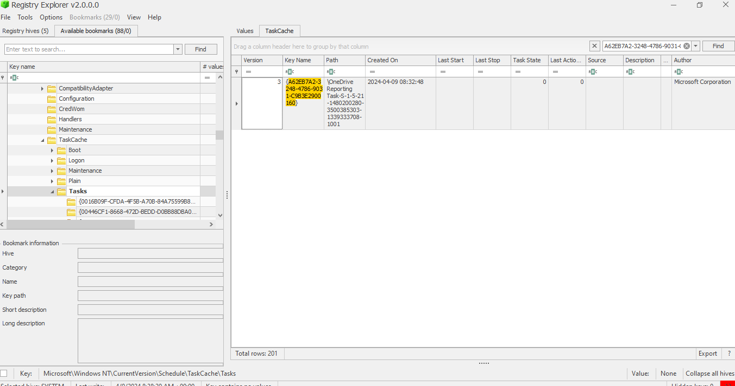

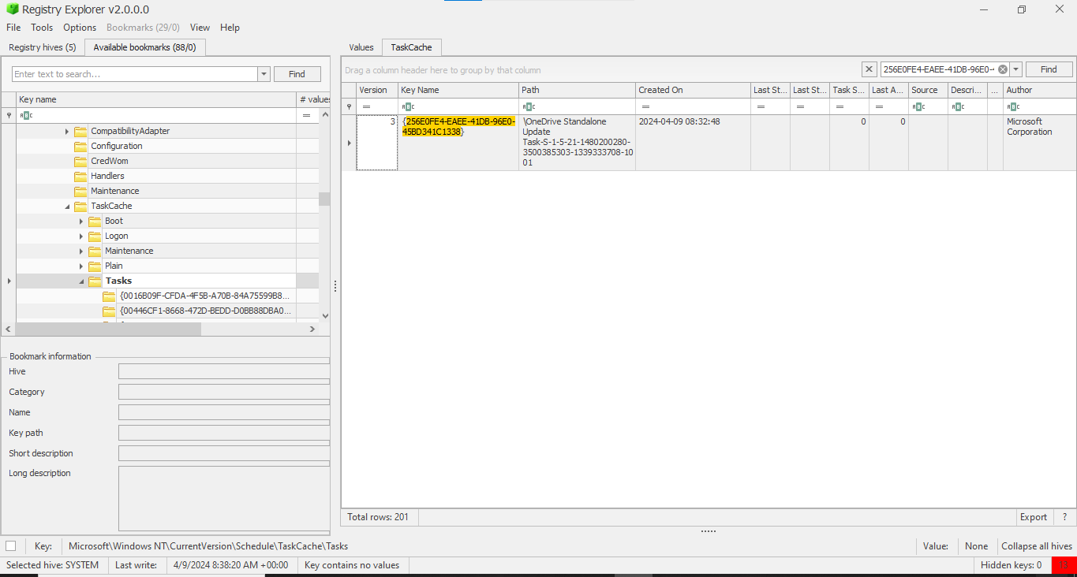

**Windows Event Log Analysis**

Windows defender 5000

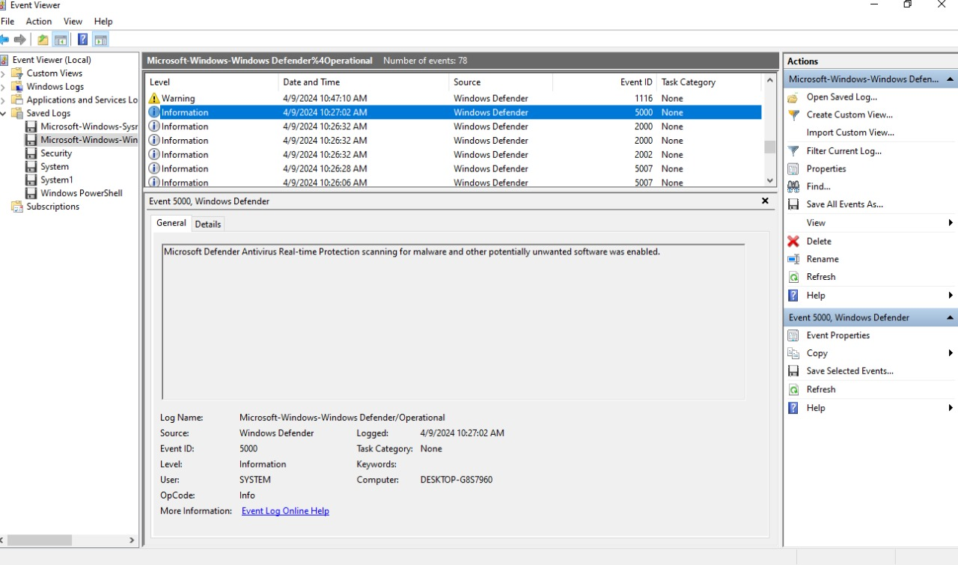

Windows defender 5001

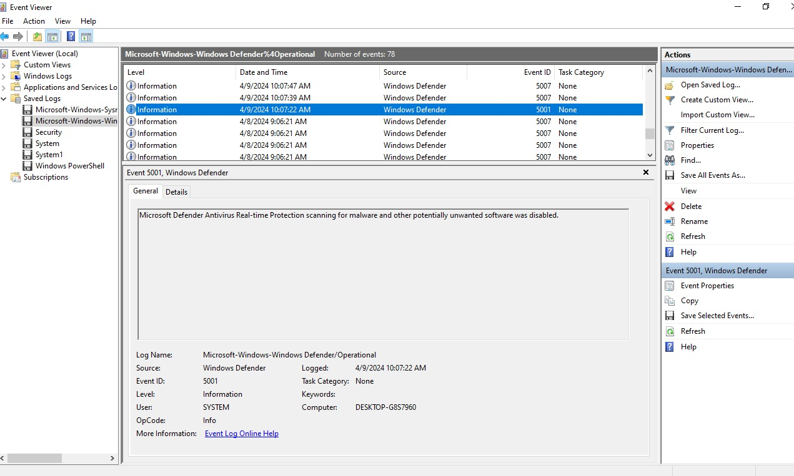

Windows Power shell 400

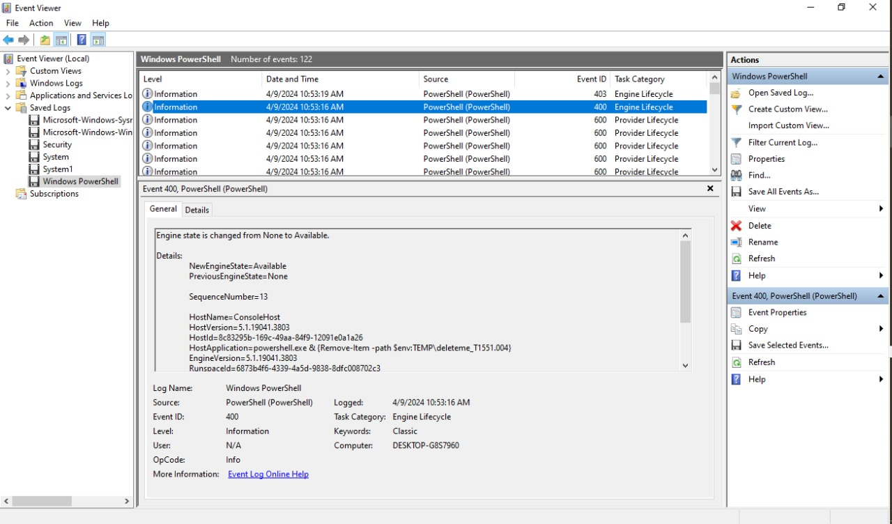

Security 4624

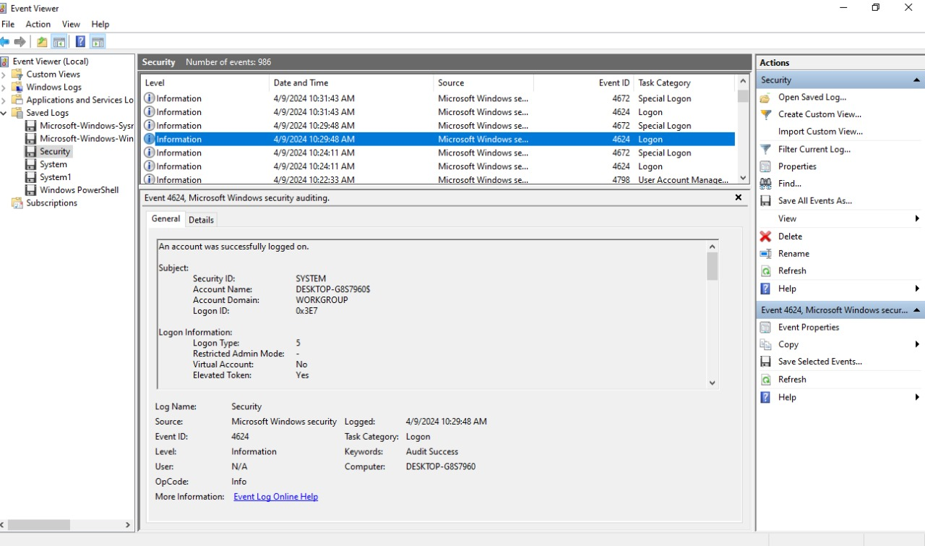

Sysmon 13

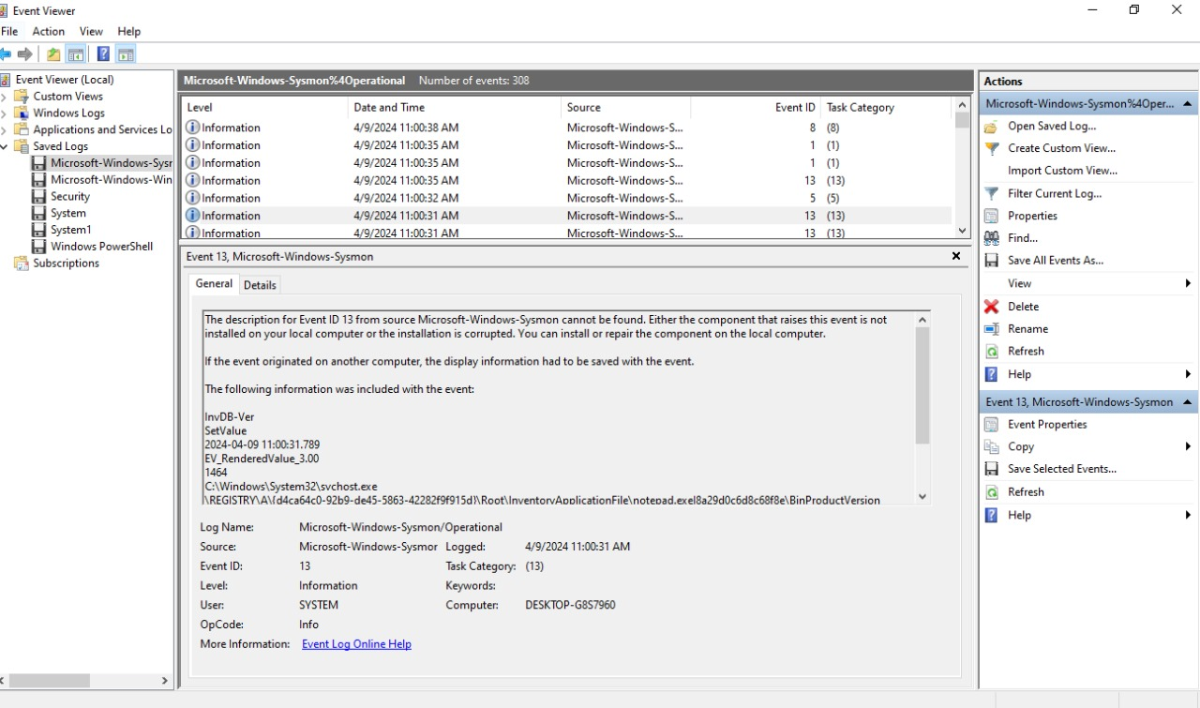

Sysmon 1

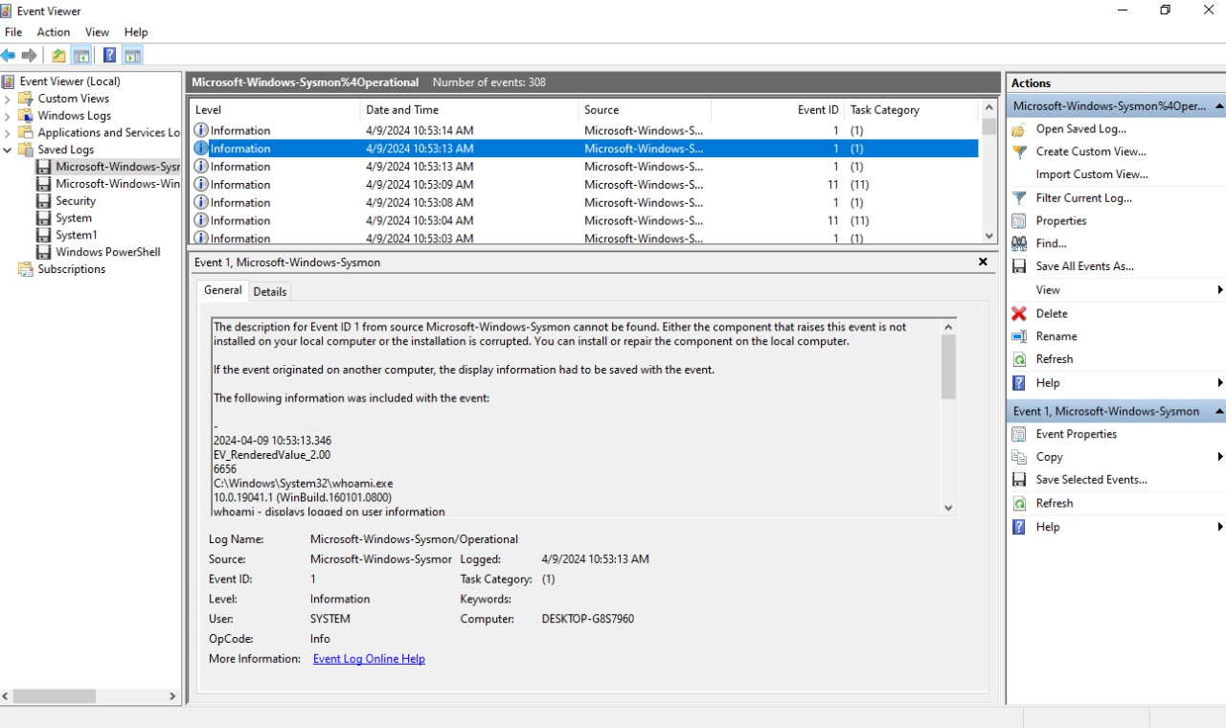

Sysmon 11,3

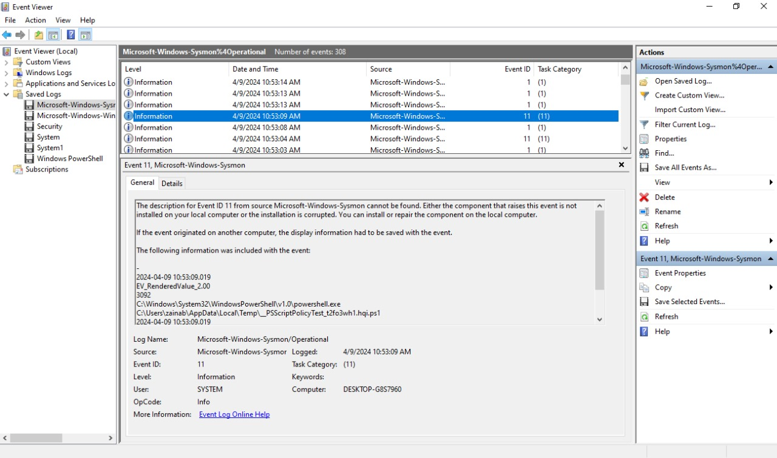

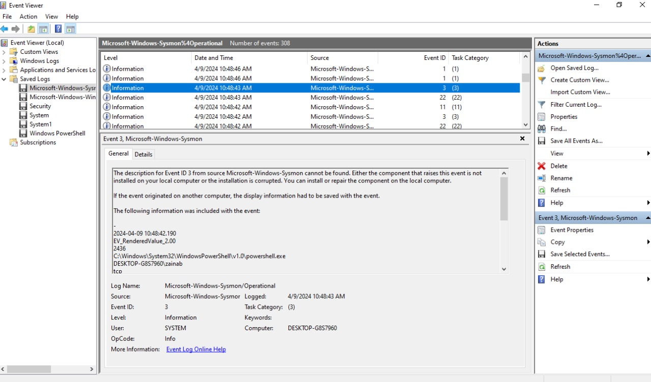

System 7624

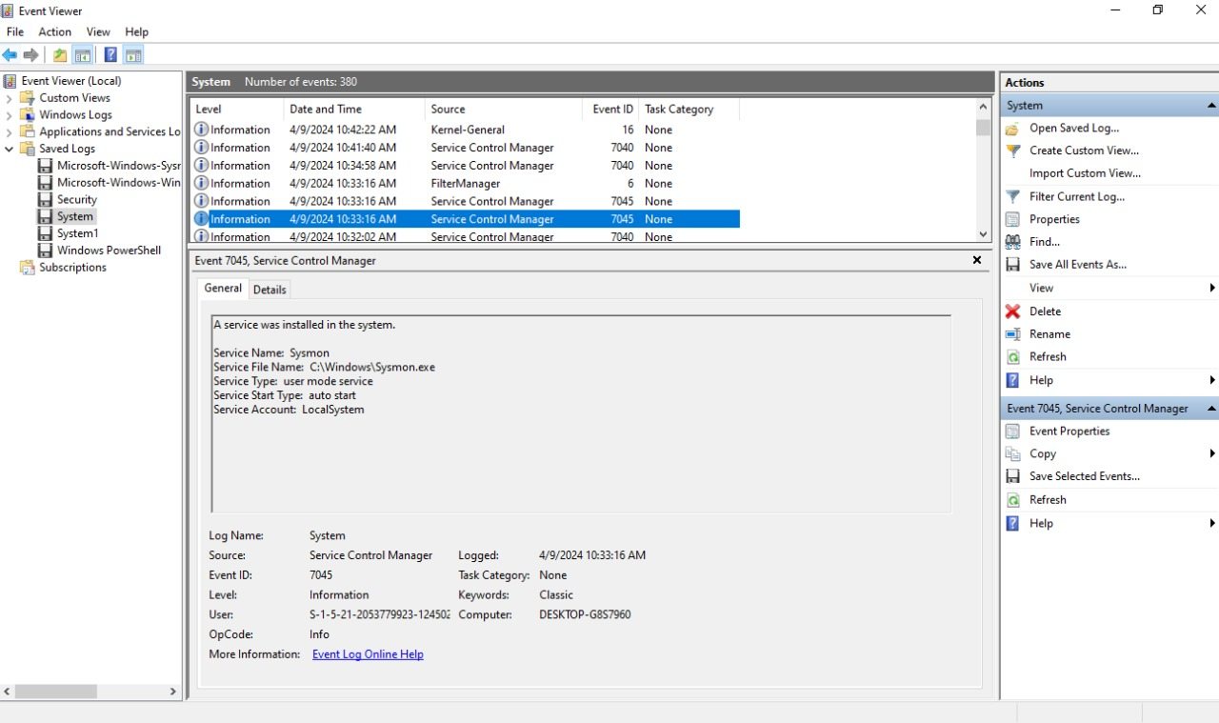

Other tools event log explorer

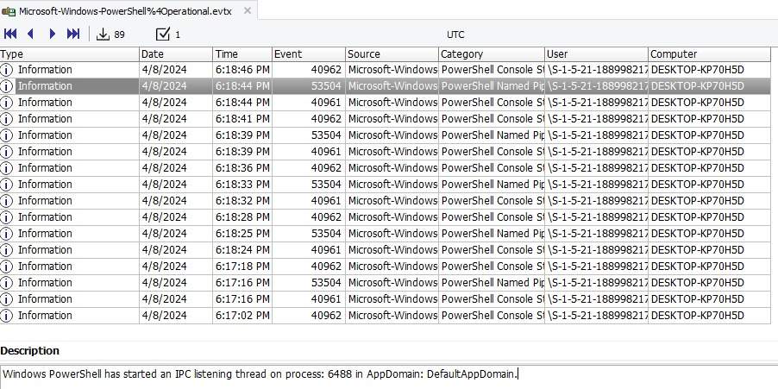

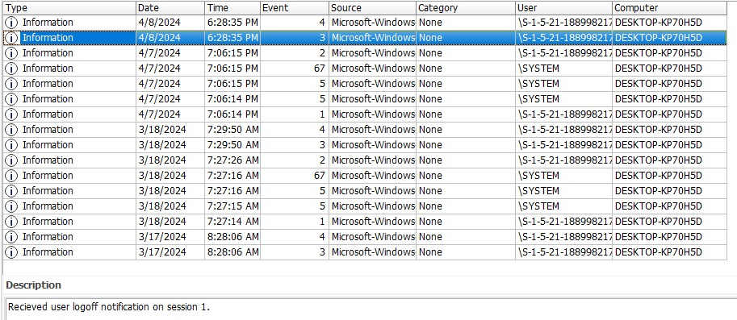

**Memory analysis**

Hybersif.sys, Swapfil.sys, pagefile.sys found in ftk

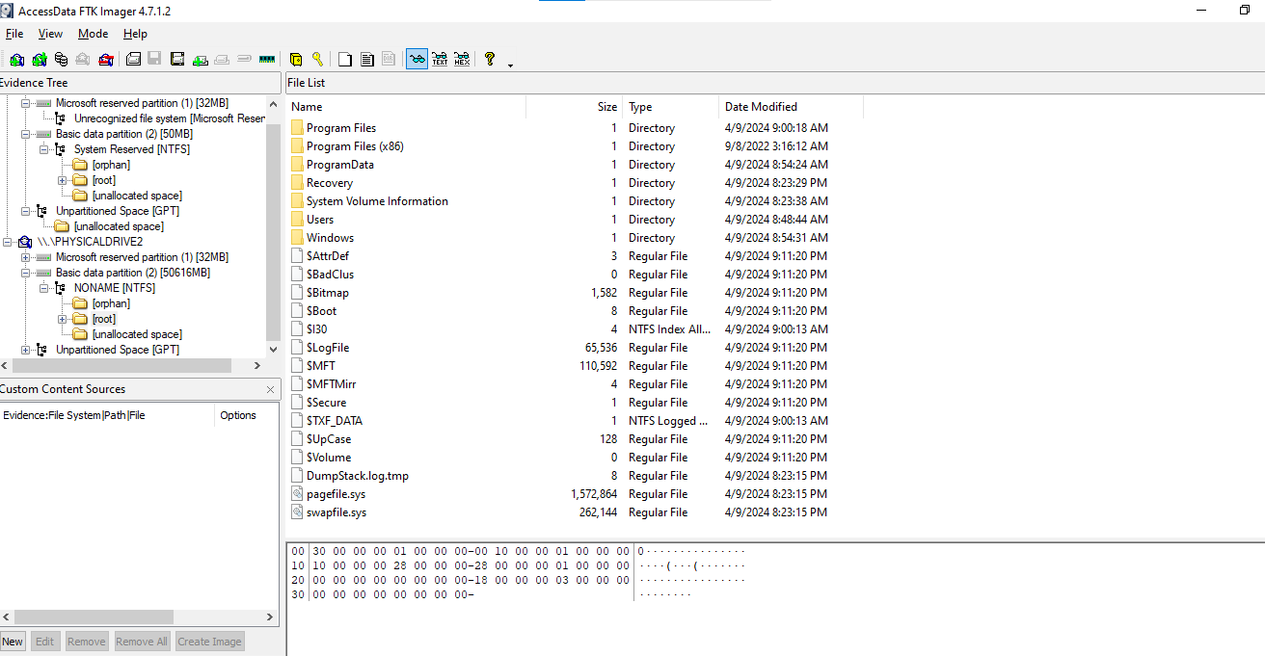

Analyzing memory file using votality3

WINDOWS INFO

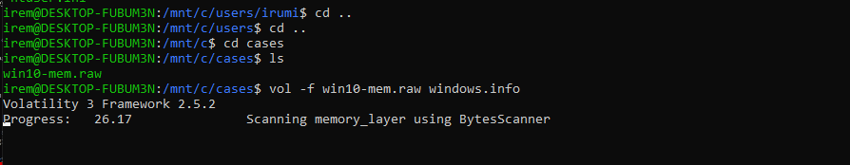

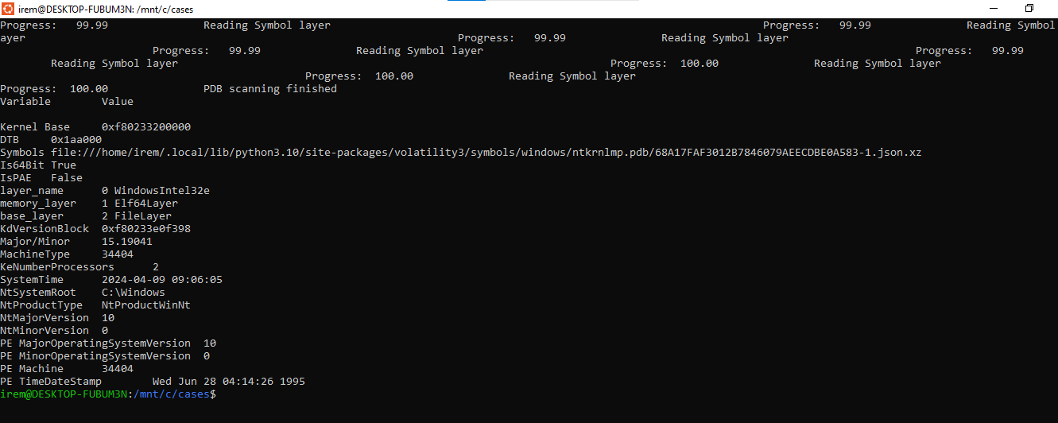

Analyzing running process on windows

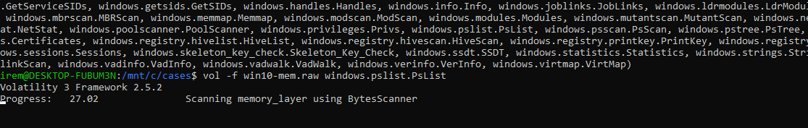

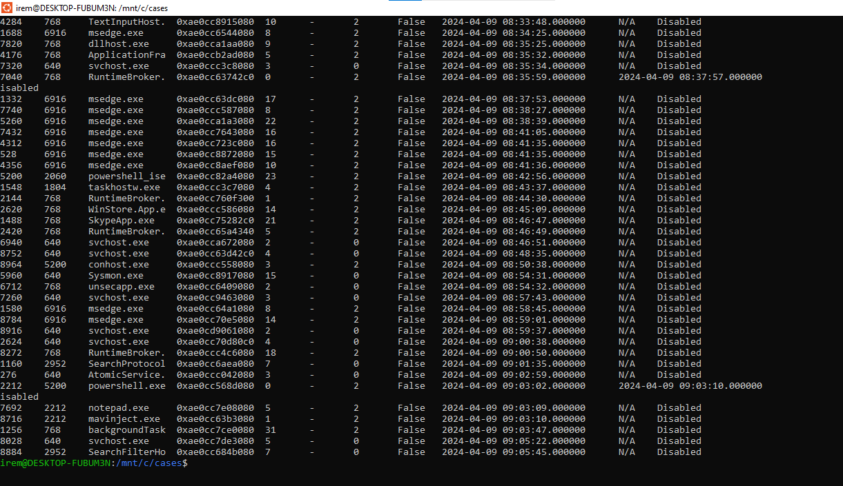

Suspicious process notepad.exe atomic service maninject.exe

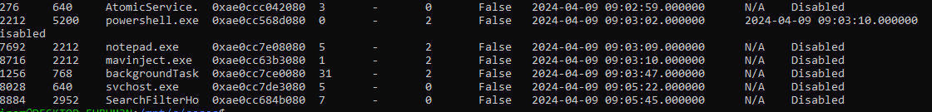

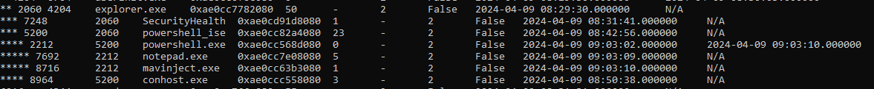



PID of suspicious processes?

powershell.exe 5200

notepad.exe 7692

AtomicService.exe 276

**Scanning for atomic service process dump**

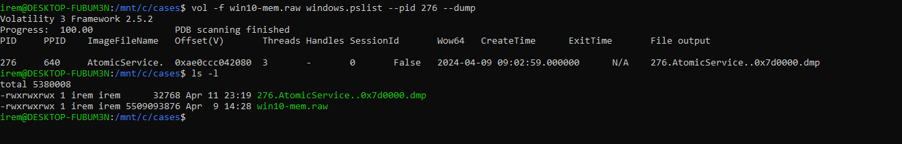**Strings for dump**

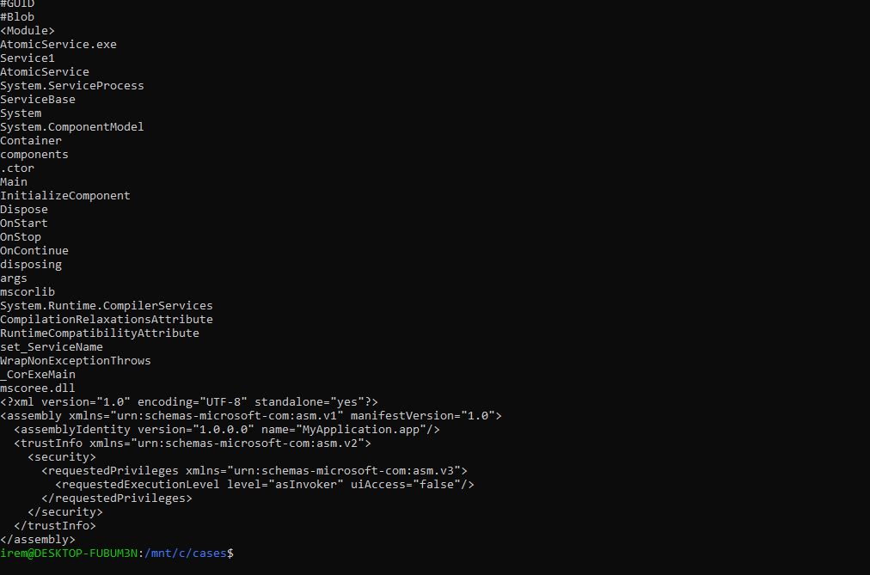

**Shasum for hash of dump**



**Searching on virus total for any report related to this**

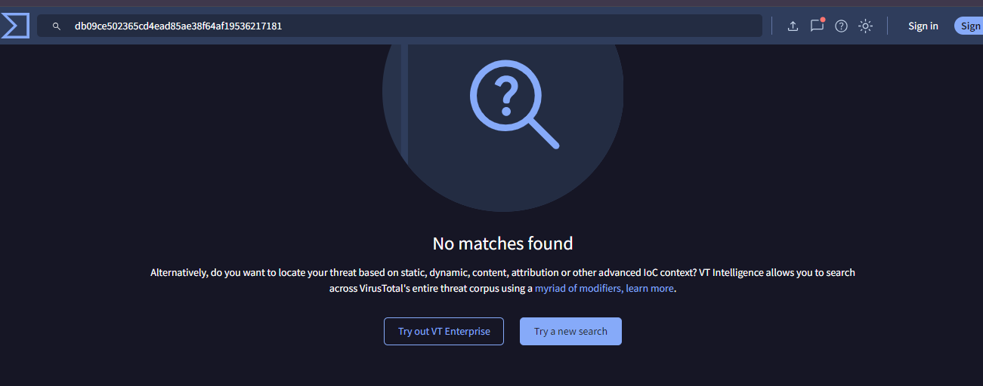

**Suspicious key**

0xd485ba67f000 \REGISTRY\A\{8EB583B0-3CE2-4FFB-887E-4D919091B4A7} Disabled



